**NEWCOMER PROGRAM EXECUTIVE SUMMARY (UPDATED FEB. 2016)**

**I. OVERVIEW**

The dramatic increase of newcomers in Oakland Unified School District is an urgent and compelling issue that requires a systems-level response. Most of our newest arrivals fall into the status of refugee, asylee, and/or Unaccompanied Minor and require intensive and specialized services to meet their academic, socio-emotional, and mental health needs. At the same time, we are seeking ways to build on the rich assets that our newcomers bring to their learning and that of their community, including linguistic and cultural diversity, global perspectives and tremendous resiliency and commitment to their education.

**II. CURRENT STATE**

A Newcomer is defined as a student who has been in the United States for less than 3 years and who speaks a language other than English at home. 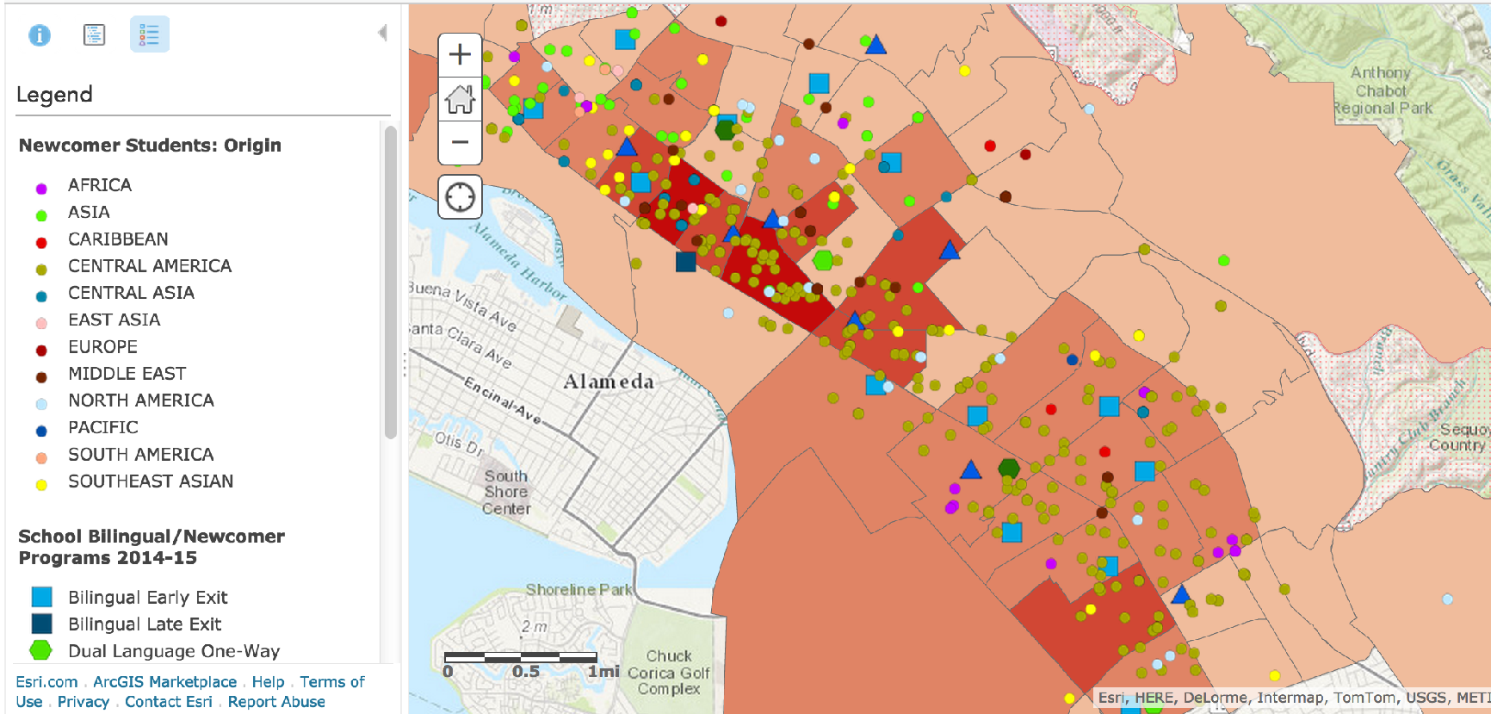

As of January 11th, 2016 Oakland Unified School District (OUSD) serves 1,916 newcomers representing a 27% increase from the same time in AY 2014-15, with more students arriving every day.

As demonstrated in the map, newcomers arrive in Oakland from all over the world, with the majority coming from Guatemala, El Salvador, China, Mexico, Yemen, and Honduras. The top home languages spoken among our newcomers are Spanish, Indigenous languages such as Mam, Arabic, Cantonese/Mandarin, and Vietnamese. Newcomers are heavily concentrated in a few areas within Oakland, principally East Oakland, the Fruitvale District, West Oakland and Downtown Oakland[1].

This drastic rise in numbers of newcomers is predominantly attributed to refugee students and unaccompanied minors, many of whom are fleeing violence, human trafficking or persecution in their home country. Since 2013, the number of youth who have arrived in Oakland and have been categorized as newcomers has grown rapidly with projections that by the fall of 2016, one in seven high school students in OUSD will be from this population. The majority of our newcomers require specialized services and supports in order to ensure they graduate college, career, and community ready. In many cases, students fall under two or more of these categories:

* **Students with Interrupted Formal Education (SIFE):** Immigrant students who come from a home in which a language other than English is spoken and 1) Enter a United States school after the second grade; 2) Have had at least two years less schooling than their peers; 3) Function at least two years below expected grade level in reading and mathematics; and 4) May be pre-literate in their first language.
* **Refugee/ Asylee:** Students who have been forced to leave their country in order to escape war, persecution, or natural disaster. Refugees generally have special visas to enter the country. Asylees apply for visas once in the US; many apply, but few receive visas.
* **Unaccompanied Minors:** Undocumented minors are children who cross the border without parents or guardians and are apprehended by immigration officials. Unaccompanied minors are federally referred to as Unaccompanied Alien Children (UAC). Once these children are released to a sponsor, they may enroll in US schools.
* **Children of Migrant Families:** These students are grouped with Unaccompanied Minors for most purposes, but technically different as they crossed the border in the company of a family member. They receive the same supports in OUSD as Unaccompanied Minors and go through similar legal proceedings.

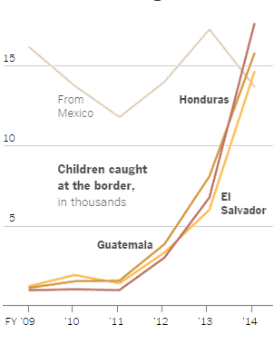

**OUSD CURRENT NEWCOMER PROGRAMS**

OUSD has several newcomer programs. The table below indicates our current programs for Newcomers.

|  |  |  |  |
| --- | --- | --- | --- |
| Level of School |  | Schools with formalized and developing newcomer programs | |
| High Schools |  | Castlemont  Fremont High School  Oakland High School  Oakland International High School | |
| Middle Schools |  | Alliance  Bret Harte  Melrose Leadership Academy  Urban Promise Academy  Roots  Roosevelt Middle School  Westlake Middle School | |
| Elementary Schools with developing programs |  | Bridges  Esperanza/Korematsu  Franklin  Garfleld  Manzanita Community |  |

**III. RATIONALE AND RESEARCH**

**EFFECTIVE NEWCOMER PROGRAMS DEMONSTRATE THE FOLLOWING 5 PRACTICES**

Because Newcomers are an especially high-need population, there are a number of critical conditions that should be in place to ensure we are setting our Newcomers up to be career, college, and community ready upon graduation. Research[2] indicates effective newcomer programs encompass the following 5 practices:

|  |  |
| --- | --- |
| PRACTICE | Rationale and Research |
| Equity Centered Master Scheduling and Transitions | * A robust intake process, including transcript analysis, to identify prior schooling as well as proficiency levels in math and home language and literacy * Clear entrance criteria, which place students in newcomer programs only when appropriate. * Strictly enforced exit criteria and procedures, which enable students to transfer smoothly, from newcomer programs to mainstream classrooms * A program structure that can accommodate mid-year entry of students and allows flexible, individualized movement through newcomer and mainstream course offerings * Students grouped in cohorts to allow for teams of teachers to collaboratively provide targeted instruction and case management to a shared group of students * Teachers assigned to no more than two academic preps in order to focus their attention on providing targeted instruction to one of the most vulnerable student populations * A low teacher/student ratio to provide more individualized instruction |
| Instructional Model | Instructional models should incorporate the following elements:   * ***Content-based language and literacy instruction:*** language and literacy are taught in a way that deepens content knowledge * ***Strategic Use of Home Language:*** home language is used to develop content knowledge as well to support aid in the comprehension of English texts and class discussion * ***Heterogeneous grouping:*** structured opportunities for newcomers to work collaboratively with more advanced ELLs and native English speakers * ***Extended Learning Opportunities:*** Targeted summer school, after school and internship programs * ***Assessments***: systematic assessment of students’ strengths and needs as well as ongoing monitoring of students’ progress |
| Professional Development | * Extensive professional assistance for all teachers and support staff who interact with newly arrived students before, during and after enrollment in newcomer programs * Training on curriculum development and instructional strategies for newcomer students for all ELD and content-area teachers * Training for all staff on issues of cross-cultural conflict, trauma based-behaviors and legal issues affecting immigrant students |
| Family Engagement and Student Social Services | * Family engagement activities, which take into account the linguistic, cultural, legal and socio-economic needs of all newcomer families * Bilingual support staff that can serve as liaisons between the schools and the community and who can link families to needed health and social services * Strong community partnerships that can provide access to a wide range of support services such as counseling, tutoring, mentorship, gang intervention, parent workshops, health and legal services, and interpreters |
| Staffing | In order to support the implementation of effective newcomer programs, the following staffing is recommended to ensure success:   * For secondary schools only: 4 teachers (ELA, Math, Science, History) for each cohort of 100 students, in addition to a PE and an elective teacher as needed * TSA - Instructional Coach dedicated to coaching, co-teaching, and curricular support * Community Schools Program Manager/Newcomer Case Manager dedicated to newcomer services * Academic Counselor dedicated to newcomer students at each site * Dedicated administrator to hold newcomer work (teacher recruitment and evaluation, student discipline, etc.) * Within a school, newcomer programs are of substantial scale involving multiple teachers and staff and, in secondary, a variety of class offerings. |

**SPOTLIGHT ON TWO NEWCOMER PROGRAM MODELS**

|  |  |
| --- | --- |
| Internationals Model (Secondary) | Dual Language Model (Primary) |
| At International high schools, a badge of prestige replaces the “stigma” of immigrant status for students, families, and faculty.  Within the network, every teacher is a language teacher as well as a teacher of academic content and skills. The educational process takes place in a heterogeneous, learner-centered, collaborative, and activity-based environment. Students are organized in diverse clusters that work with the same team of teachers over 1-2 years. Classes are mixed according to age, grade, academic ability, prior schooling, native language, and linguistic proficiency. They are interdisciplinary and rigorous, and the curriculum includes literature, social studies, math, science, the arts, technology, and physical education.  The Internationals’ pedagogical approach to educating English language learners is based upon 5 Core Principles   * Heterogeneity and collaboration * Experiential Learning * Language and content integration * Localized autonomy and responsibility * One learning model for all | Dual language refers to any program that provides literacy and content instruction to all students through two languages and that promotes bilingualism and bi-literacy, grade-level academic achievement, and multicultural competence for all students.  As OUSD grows and expands its high-quality dual language programs, there is an opportunity to leverage this work to also support our newcomer students. In particular, newcomers both benefit from and are an asset to dual language programs because they:   * Use their cultural background as an asset to the community * serve as “language models” * Are placed into language rich environments, with at least half the content in their home language * Benefit from an emphasis on initial fluency in their own language   Dual language programs can take several formats including two-way 50/50, two-way 90/10, one-way 50/50 and one-way 90/10. For further explanation, see the accompanying Dual Language program expansion proposal. |

**IV. 2015-16 NEWCOMER WORK PLAN**

**Goal:** Articulate and provide guidance on newcomer programs, support expansion of newcomer programs at select sites, solidify systems to allocate resources to newcomers.

**High-level Strategy, Project or Workstreams:**

1. **Provide quality newcomer programs that proactively meet the demands of increasing newcomer enrollment.**
2. **Provide research-based newcomer-specific resources and professional development to newcomer teachers and leaders.**
3. **Establish and recognize newcomer programs as specialized programs with aligned central policies and resources.**
4. **Ensure access to culturally sensitive mental health, health, legal services and other social services for newcomer students and their families.**

|  |
| --- |
| **Strategy 1**  **Support the growth and development of programs that proactively meet the demands of increasing newcomer enrollment.**   1. Create a design process for emerging newcomer schools- support new and expanding programs in following a site-based implementation plan. 2. Support expansion of newcomer programs at Intensive Support Schools (Castlemont and Fremont) as well as planning process for schools answering the Fall Call for Quality Schools. 3. Develop defined models of elementary and secondary newcomer programs including course offerings, scheduling, amount of mainstreaming, class sizes, and assessments. 4. Provide principals the opportunity to collaborate and engage in best practices for newcomer programs. |
| **2015-16 Success Metrics:**   * Site-based implementation plans for every new and developing program based on ELLMA recommended design process; Network office holds schools accountable to these plans. |
| **Action Steps:** |
| * Support MCS and Esperanza in implementing elementary newcomer programs supported by centrally funded TSAs. * Through partnership with MCS and Esperanza begin to define successful models for elementary newcomer programs. * Engage in planning with MCS, Esperanza, and potential additional elementary newcomer hub sites to build upon learning from 2015-16 school year. * Support workshops and site visits related to the Fall Call around newcomer program design. * Engage in and include others in exploration and research on effective newcomer program models outside of Oakland through the Fall Call process. * Provide continued workshops and monthly consultations and fine-tuning to schools engaged in planning through the Fall Call process. * Engage with design principals at Fremont and Castlemont during design process to provide models of effective newcomer program models. * Partner with other emerging or developing secondary newcomer program sites to identify next steps to strengthen programs and craft implementation plans.   + Alliance   + Bret Harte   + MLA   + Roosevelt   + Westlake   + Frick   + UPA   + Oakland High   + Castlemont * In partnership with content area specialists, examine curricular options for social studies, math, science, and elementary ELD. * Prospect for assessment tools to measure English language development in Newcomers for intake, placement, and progress monitoring that includes multiple measures of assessment. |
|
|
|
|
|
|
|
|
|
|

|  |
| --- |
| **Strategy 2**  **Provide research-based newcomer-specific resources and professional development to newcomer teachers and leaders.**   1. Develop research-based toolkit for newcomer programs (curriculum, assessment, instructional strategies) for all grade levels. 2. Develop 3-tiered professional learning model for newcomer teachers via independent online learning, monthly collaborative learning and intensive inquiry-based learning with Mills Teachers Scholars. 3. Leverage Oakland International as a newcomer lab school. |
| **2015-16 Success Metrics:**   * Research-based “Newcomer Toolkit” (online version); * Newcomer teachers and leaders are able to indicate ways their practice and/or school has improved based on provided professional learning; evidence of implementation of PL through the Teaching Channel. * Staff from all emerging and developing newcomer sites will have visited OIHS or UPA to observe classrooms, PLCs and COST. |
| **Action Steps:** |
| * Identify major resource and information needs from sites in order to define scope of Newcomer Toolkit. * Gather, create, synthesize, and distribute research-based information and tools in response to site requests while cataloging for inclusion in Newcomer Toolkit. Continually refine resources based on feedback and experience with sites. * Compile resources provided to sites throughout the year into a comprehensive and public Newcomer Toolkit that is publicly accessible. * Establish course sequence for professional development for the year and finalize partnerships with professors. * Provide monthly professional development modules on Teaching Channel platform which can be used individually, in an in-person site-based PD, or for central PD. * Partner with Mills Teacher Scholars to provide year-long inquiry based collaborative Tier 3 professional development centered on effective practices for newcomers. * Provide intensive coaching, professional development, program guidance, instructional frameworks to high schools with established newcomer programs. * At two developing newcomer sites, conduct weekly coaching visits, support use of appropriate newcomer curriculum, provide connections to professional development and other resources. * Provide differentiated coaching and PD support to middle school newcomer programs based on site needs, status of program, resources available at site. * Support the piloting of curricula:   + Math intervention/ST Math   + Continued National Geographic piloting   + Imagine Learning   + Summer PD Opportunities |
|
|
|
|
|
|
|
|
|
|

|  |
| --- |
| **Strategy 3**  **Establish and recognize newcomer programs as specialized programs with aligned central policies and resources.**   1. Update OUSD data systems to include all newcomer types (SIFE, UAC, Refugee) and time in country (Y1, Y2, Y3). 2. Define clear roles and responsibilities for the central and site intake process (assessment and placement), and standardize practices. 3. Establish funding sources that account for additional students enrolling in newcomer programs after initial 20 days. |
| **2015-16 Success Metrics:**   * Newcomer programs are recognized as specialized programs (OUSD adopts funding formula, intake and enrollment, data systems.) * Develop annual literacy targets that will be tracked on Illuminate and/or AERIES; Newcomer subgroups are tagged in AERIES/ Illuminate. |
| **Action Steps:** |
| * Define and communicate which sites are formal newcomer program sites. * Establish ELD course sequence, including course of study and associated curriculum, for high school newcomers that enable them to meet A-G requirements. * Articulate a proposed system for classifying newcomers that can be used in OUSD data systems. * Collect and synthesize useful data about newcomer enrollment and use that to inform budget development process. * Enlist the budget office in revisiting the way newcomer programs are funded in advance of the budget development process. * Articulate systems at the student assignment office to facilitate newcomers being assigned to schools with appropriate programs when possible. * Design stronger systems for communication between student assignment office and school sites at the time of newcomer enrollment. * Update data systems with new system of newcomer classification to allow identification of newcomers and data reports disaggregated by language proficiency. |
|
|
|
|
|
|
|

|  |
| --- |
| **Strategy 4**  **Ensure access to culturally sensitive mental health, health, legal services and other social services for newcomer students and their families.**   1. Advocate and support the development of resources and systems to provide access to health and mental health and other social services. 2. Support implementation of parent train-the-trainer program for newcomer students and families to disseminate resources and information. |
| **2015-16 Success Metrics:**   * Increase in newcomer family use of mental health, health, family engagement, legal and other social services facilitated by OUSD. * Published resource guide for health and mental health services. |
| **Action Steps:** |
| * Establish formal connections with community support partners around providing comprehensive services and information to newcomers at all sites. * Define guidelines (to be included in the Newcomer Toolkit) for site intake of newcomers to ensure that they are connected at the time of enrollment with necessary services, such as, but not limited to:   + Refugee/asylee services   + Transportation   + Legal aid   + Mental health services * Identify point persons at each site that support the intake of newcomers and provide them with intake best practices and resources. Advocate for their inclusion in COST when possible. * Partner with Restorative Justice office to identify best practices for engaging newcomer students with restorative service providers. * Uniform referral process for newcomer sites |
|
|
|
|

1. *OUSD Research, Assessment and Data, Comprehensive Student Data Roster: October 2014;* 183 Newcomers in the 94601; 77 Newcomers in the 94606; 69 Newcomers in the 94612; 57 Newcomers in the 94603
2. Access and Engagement: Program Design and Instructional Approaches for Immigrant Students in Secondary School by Aida Walqui (2000); Helping Newcomer Students Succeed in Secondary Schools and Beyond by Deborah Short and Beverly Boyson from the Center for Applied Linguistics (2012); Ninth Grade Counts: Strengthening the High School Transition for English Language Learners (2012).