Instructions for SSC Meetings

To ensure that minutes are easy to understand and that your site meets all legal requirements, WCCUSD SSCs are required to use the same templates with monthly agenda topics that match the SPSA planning cycle.

WCCUSD SSC Cover Page Template:  This template ensures that SSC members are always listed on the cover page with their term limits. Please remove one row for elementary composition since they have a maximum size of 10 members (review guide for clarification if needed).  Please remember to change the section in yellow to indicate the academic year (this will prevent confusion in the future when you need to submit records for audits). | 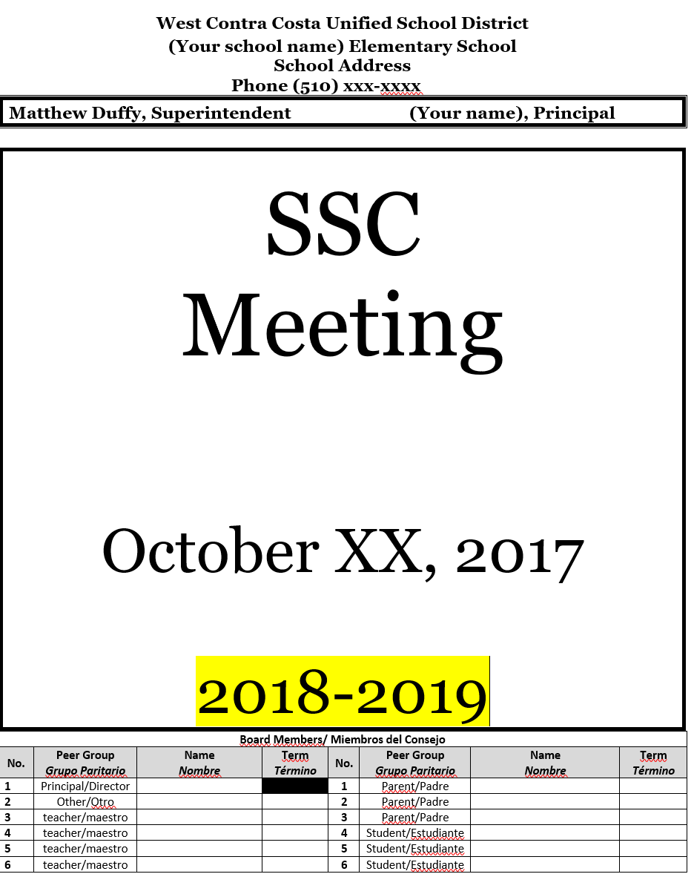
WCCUSD SSC Agenda Template:  The agenda template ensures that all agenda items indicate if the item will require a vote. All agenda items must allow for members to discuss and for public comment before a vote.  Welcome and roll call do not require discussion or a vote hence why the action sections are blank.  When an item does not require voting, remove it from the actions section.  The template does not include a section for general announcements, but you may add it at the end.  All text in English is written in bold font to make it easier to distinguish from Spanish text.  NOTE: You may, if you choose create an English only and a Spanish only agenda to make the agenda less busy if you like. | 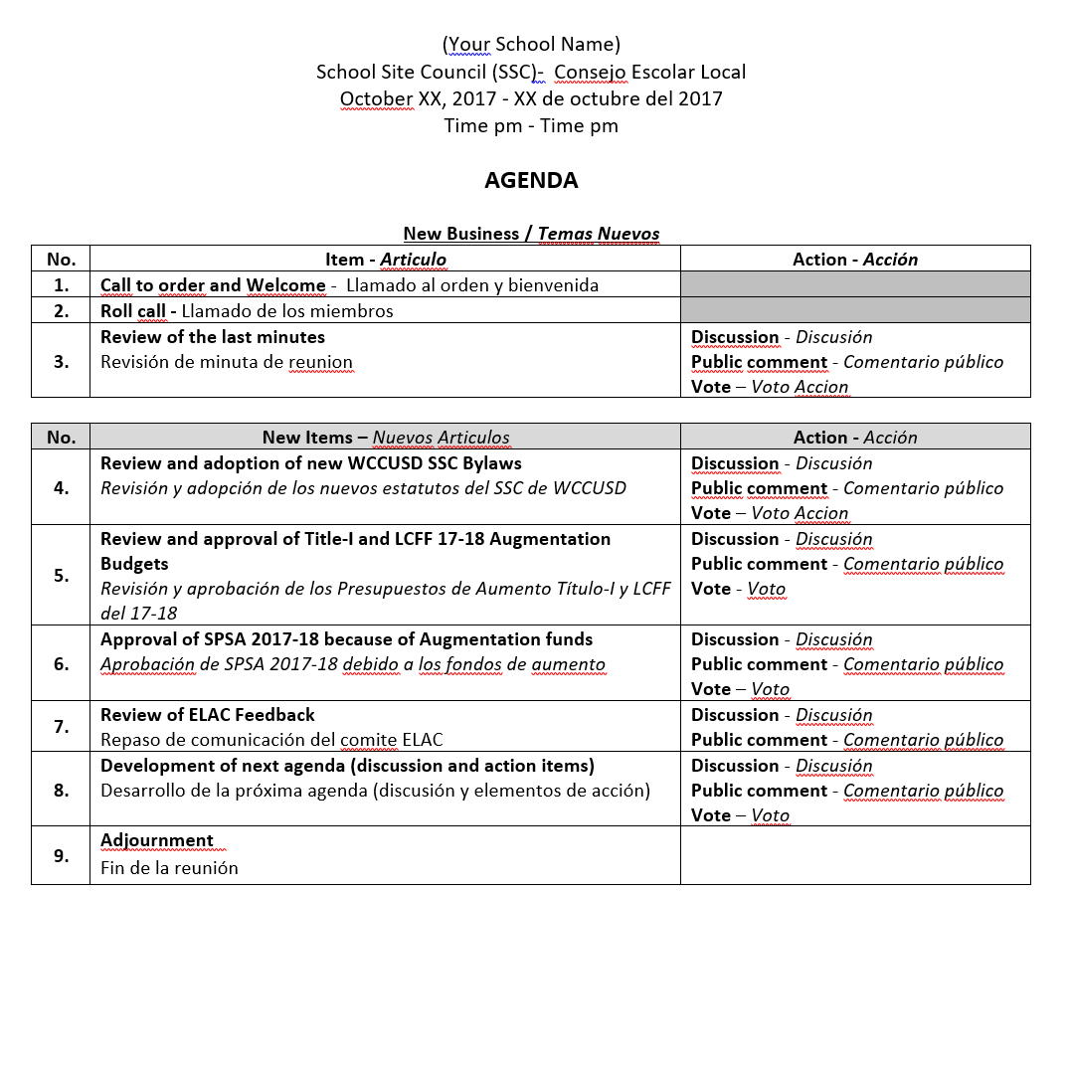
WCCUSD SSC Minutes Template:  This template includes a section to record attendance of elected members and confirm quorum.  A section to record voting member’s discussions has been provided.  This template includes a section to record public comment by guests during the meeting.  This template includes a section to record the specific motion. Please write the specific action(s) that were considered for voting..  This template includes a section to record how many voting members voted YES, voted NO, or abstained. If the agenda item was not a voting item, please mark the Non Applicable Box with an “X.”  Remember to consult the suggested phrases for each month to ensure those who read your minutes understand the actions taken at the meeting. | 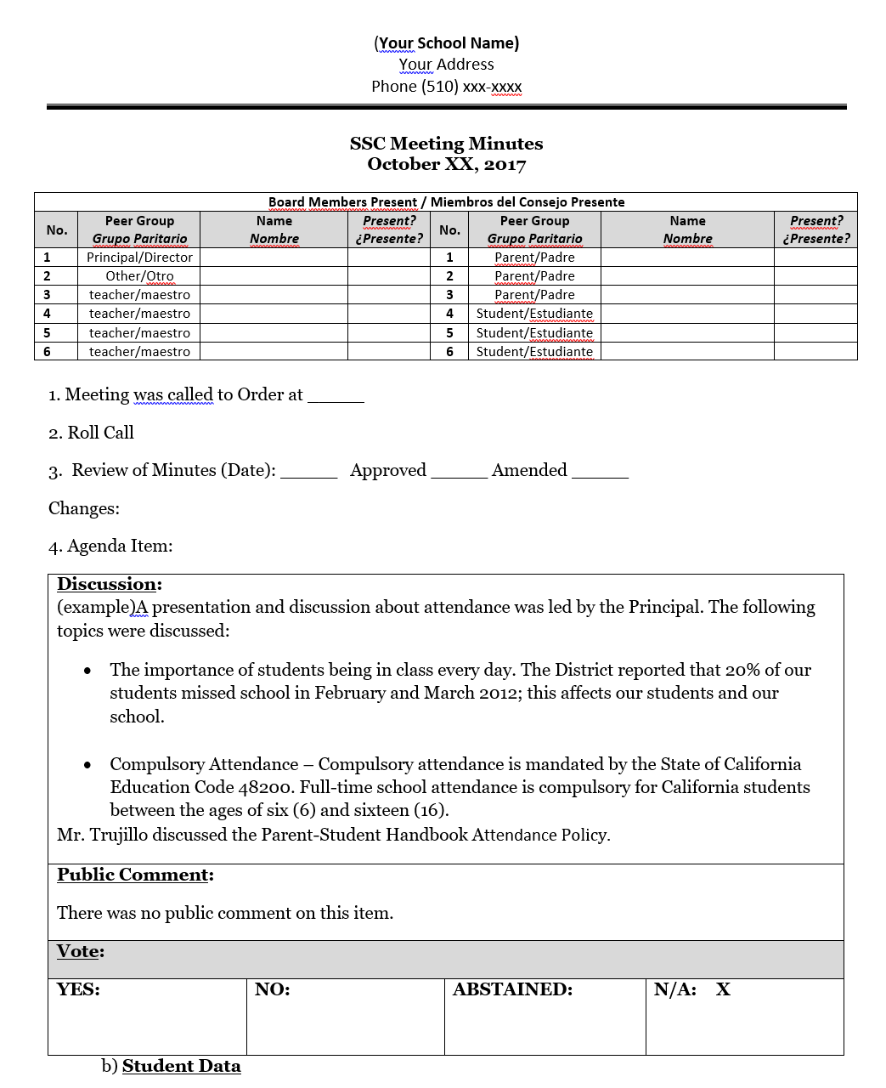
WCCUSD SSC Sign in Sheet Template:  Type the names of all elected members on the sign in sheet and collect their signature to confirm quorum.  This template includes a section for guests to sign in. | 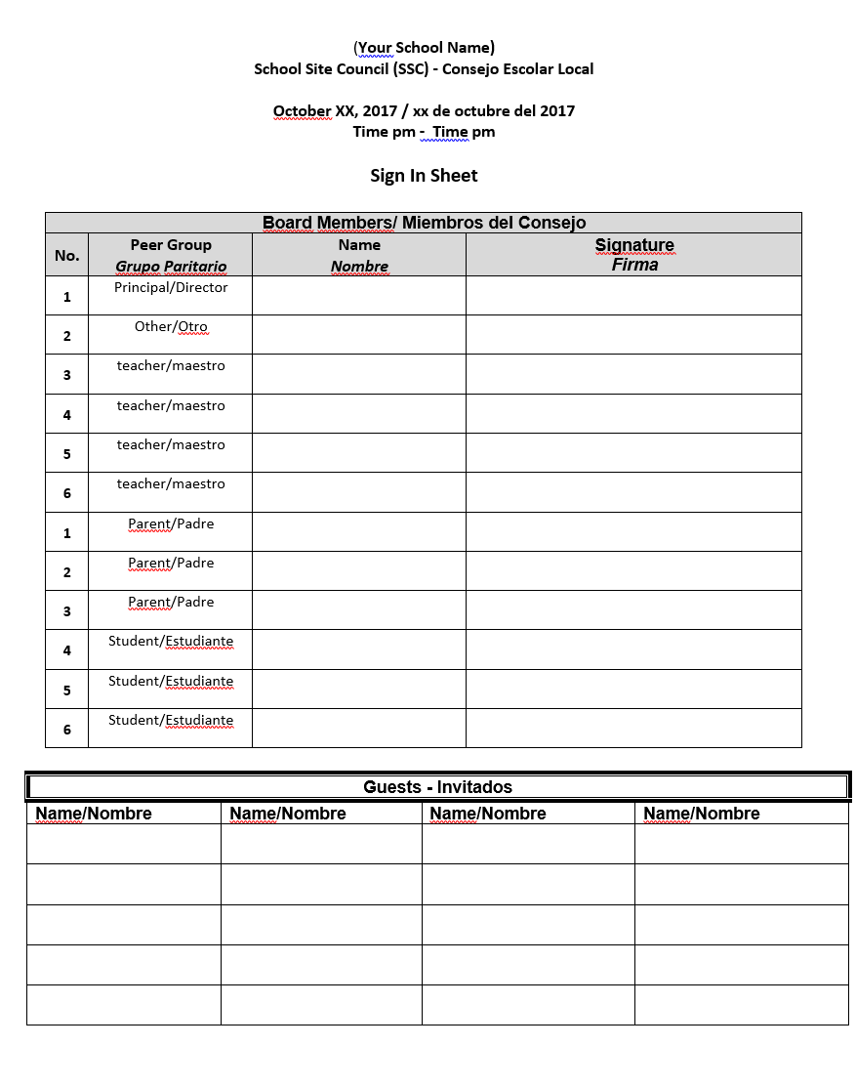
WCCUSD SSC Meeting Topics Timeline 2018-19:  The attached timeline provides already translated SSC agenda items that align with the SPSA timeline.  Copy and paste to topics for future meetings. This template starts with the October meeting topics already included.  You may add more topics to your agenda by adding additional rows and when necessary shift agenda topics to other months as needed (unless there is a hard deadline).  PowerPoint modules for each SSC meeting as well as pre-meeting resources will be provided throughout the year to help members prepare before they meet. | 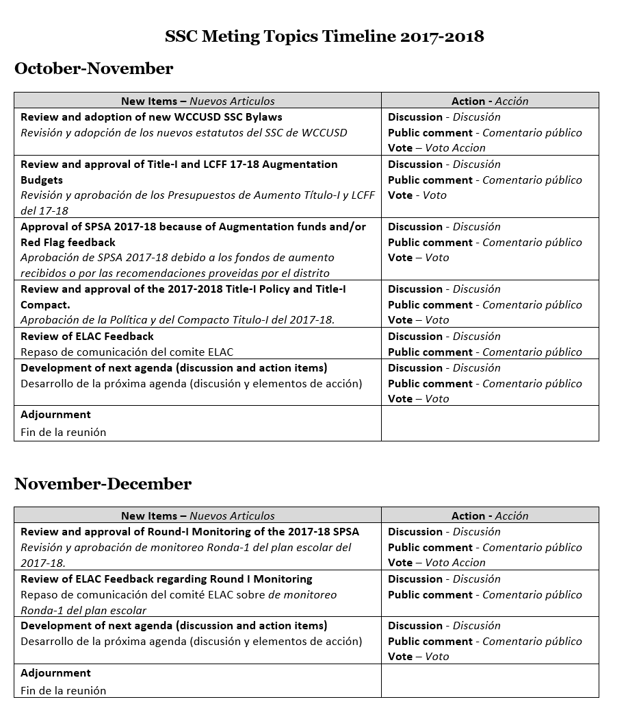
Attendance via Electronic Means:  When an SSC member attends a meeting via electronic means complete this form.  SSC member in question will have to sign form at a later date.  The SSC Chair and Principal must sign the form to confirm.  Indicate in minutes and sign in sheet the attendance of the member by writing “Electronic Attendance.”  File original form in the SSC Binder and submit to the Community Engagement Office with corresponding minutes and sign in sheet. | 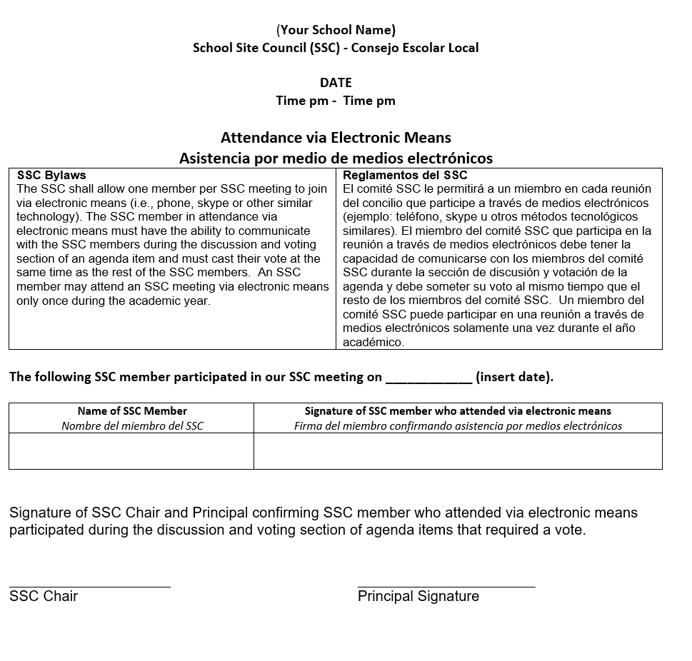

Sample Phrases to use in SSC Minutes
For Budget and SPSA Approval:
- The SSC reviewed and approved the ____ (insert name of budget(s), totaling ______.
- The SSC reviewed and approved the ____ (insert year) SPSA/School Plan.
- The SSC reviewed and approved the 2018-19 SPSA after the _______ (insert names of budgets) Augmentation budgets for 2018-19, totaling ______ were incorporated into the school plan.

For Round-I and II SPSA Monitoring:
- The SSC conducted a Round-I Monitoring of the following SPSA frames______, _______, ______ (insert name of respective SPSA frames) which the committee determined were being implemented as outlined in the SPSA and are on schedule.
- The SSC also conducted a Round-I Monitoring of the following SPSA frames______, _______,______ (insert name of respective SPSA frames) which the committee determined were behind schedule. The committee decided the following key actions would be required to ensure the strategies succeed (list actions):

For Data Analysis:
- PENDING

For ELAC Consultation:
- The elected ELAC members received training on their legal roles and responsibilities. The ELAC members then voted to delegate the responsibilities of the ELAC to the School Site Council (SSC) on _____. Delegation to the SSC will expire on _________, 20____, pending Certification from the Community Engagement Department.
- The SSC reviewed the recommendations made by the ____(insert name of school) ELAC regarding the needs of English learners. The ELAC had the following comments/suggestions: (a)__________; (b) ___________; and (c) ______________.
SSC Meting Topics Timeline 2018-2019
September-October-November
New Items – Nuevos Articulos | Action - Acción
Review and adoption of new WCCUSD SSC Bylaws  Revisión y adopción de los nuevos estatutos del SSC de WCCUSD | Discussion - Discusión  Public comment - Comentario público  Vote – Voto Accion
Review and approval of Title-I and LCFF 18-19 Augmentation Budgets  Revisión y aprobación de los Presupuestos de Aumento Título-I y LCFF del 18-19 | Discussion - Discusión  Public comment - Comentario público  Vote - Voto
Approval of SPSA 2018-19 because of Augmentation funds and/or Red Flag feedback  Aprobación de SPSA 2018-19 debido a los fondos de aumento recibidos o por las recomendaciones proveidas por el distrito | Discussion - Discusión  Public comment - Comentario público  Vote – Voto
Review and approval of the 2018-2019 Title-I Policy and Title-I Compact.  Aprobación de la Política y del Compacto Titulo-I del 2018-19. | Discussion - Discusión  Public comment - Comentario público  Vote – Voto
Review of ELAC Feedback  Repaso de comunicación del comite ELAC | Discussion - Discusión  Public comment - Comentario público
Development of next agenda (discussion and action items)  Desarrollo de la próxima agenda (discusión y elementos de acción) | Discussion - Discusión  Public comment - Comentario público  Vote – Voto
Adjournment
Fin de la reunión

November-December
New Items – Nuevos Articulos | Action - Acción
Review and approval of Round-I Monitoring of the 2018-19 SPSA  Revisión y aprobación de monitoreo Ronda-1 del plan escolar del 2018-19. | Discussion - Discusión  Public comment - Comentario público  Vote – Voto Accion
Review of ELAC Feedback regarding Round I Monitoring  Repaso de comunicación del comité ELAC sobre de monitoreo Ronda-1 del plan escolar | Discussion - Discusión  Public comment - Comentario público
Development of next agenda (discussion and action items)  Desarrollo de la próxima agenda (discusión y elementos de acción) | Discussion - Discusión  Public comment - Comentario público  Vote – Voto
Adjournment
Fin de la reunión

January
New Items – Nuevos Articulos | Action - Acción
Review of budget allocations for 18-19.  Revisión y aprobación de presupuestos ya comprometido a personal para el año académico 18-19. | Discussion - Discusión  Public comment - Comentario público
Review and approval of funds for 18-19 staff commitments. Revisión y aprobación de presupuestos comprometido a personal para el año académico 18-19. | Discussion - Discusión  Public comment - Comentario público  Vote – Voto Accion
Adjournment
Fin de la reunión
February
New Items – Nuevos Articulos | Action - Acción
Pending
Adjournment
Fin de la reunión

March
New Items – Nuevos Articulos | Action - Acción
Pending
Adjournment
Fin de la reunión

April
New Items – Nuevos Articulos | Action - Acción
Pending
Adjournment
Fin de la reunión

May-June
New Items – Nuevos Articulos | Action - Acción
Pending
Adjournment
Fin de la reunión

West Contra Costa Unified School District
(Your school name) Elementary School
School Address
Phone (510) xxx-xxxx
Matthew Duffy, Superintendent (Your name), Principal

SSC
Meeting

October XX, 2018

2018-2019
Board Members/ Miembros del Consejo
No. | Peer Group  Grupo Paritario | Name  Nombre | Term  Término | No. | Peer Group  Grupo Paritario | Name  Nombre | Term  Término
1 | Principal/Director |  |  | 1 | Parent/Padre
2 | Other/Otro |  |  | 2 | Parent/Padre
3 | teacher/maestro |  |  | 3 | Parent/Padre
4 | teacher/maestro |  |  | 4 | Student/Estudiante
5 | teacher/maestro |  |  | 5 | Student/Estudiante
6 | teacher/maestro |  |  | 6 | Student/Estudiante

(Your School Name)
School Site Council (SSC)- Consejo Escolar Local
October XX, 2018 - XX de octubre del 2018
Time pm - Time pm

AGENDA

New Business / Temas Nuevos
No. | Item - Articulo | Action - Acción
1. | Call to order and Welcome - Llamado al orden y bienvenida
2. | Roll call - Llamado de los miembros
3. | Review of the last minutes  Revisión de minuta de reunion | Discussion - Discusión  Public comment - Comentario público  Vote – Voto Accion

No. | New Items – Nuevos Articulos | Action - Acción
4. | Review and adoption of new WCCUSD SSC Bylaws  Revisión y adopción de los nuevos estatutos del SSC de WCCUSD | Discussion - Discusión  Public comment - Comentario público  Vote – Voto Accion
5. | Review and approval of Title-I and LCFF 18-19 Augmentation Budgets  Revisión y aprobación de los Presupuestos de Aumento Título-I y LCFF del 18-19 | Discussion - Discusión  Public comment - Comentario público  Vote - Voto
6. | Approval of SPSA 2018-19 because of Augmentation funds and/or Red Flag feedback  Aprobación de SPSA 2018-19 debido a los fondos de aumento recibidos o por las recomendaciones proveidas por el distrito | Discussion - Discusión  Public comment - Comentario público  Vote – Voto
7. | Review and approval of the 2018-2019 Title-I Policy and Title-I Compact.  Aprobación de la Política y del Compacto Titulo-I del 2018-19. | Discussion - Discusión  Public comment - Comentario público  Vote – Voto
8. | Review of ELAC Feedback  Repaso de comunicación del comite ELAC | Discussion - Discusión  Public comment - Comentario público
9. | Development of next agenda (discussion and action items)  Desarrollo de la próxima agenda (discusión y elementos de acción) | Discussion - Discusión  Public comment - Comentario público  Vote – Voto
10. | Adjournment  Fin de la reunión

(Your School Name)
Your Address
Phone (510) xxx-xxxx

SSC Meeting Minutes
October XX, 2018

Board Members Present / Miembros del Consejo Presente
No. | Peer Group  Grupo Paritario | Name  Nombre | Present?  ¿Presente? | No. | Peer Group  Grupo Paritario | Name  Nombre | Present?  ¿Presente?
1 | Principal/Director |  |  | 1 | Parent/Padre
2 | Other/Otro |  |  | 2 | Parent/Padre
3 | teacher/maestro |  |  | 3 | Parent/Padre
4 | teacher/maestro |  |  | 4 | Student/Estudiante
5 | teacher/maestro |  |  | 5 | Student/Estudiante
6 | teacher/maestro |  |  | 6 | Student/Estudiante

1. Meeting was called to Order at _____
2. Roll Call
3. Review of Minutes (Date): _____ Approved _____ Amended _____
Changes:
4. Agenda Item:
Discussion:
(example)A presentation and discussion about attendance was led by the Principal. The following topics were discussed:
- The importance of students being in class every day. The District reported that 20% of our students missed school in August and September 2018; this affects our students and our school.

- Compulsory Attendance – Compulsory attendance is mandated by the State of California Education Code 48200. Full-time school attendance is compulsory for California students between the ages of six (6) and sixteen (16).
Mr. Trujillo discussed the Parent-Student Handbook Attendance Policy.
Public Comment:
There was no public comment on this item.
Motion:
YES: | NO: | ABSTAINED: | N/A: X

b) Student Data
Discussion:
A report was provided by the ILT on the latest CST results which identified the following areas of growth:
- X
- Y
- Z

Public Comment:
Mr. X a guest at the SSC expressed his concerned with the lack of technology based intervention and test prepping.
Ms. X suggested that the SSC should visit X school that has been tackling the same time of academic issues and has been successful.
Motion:
Ms. X motioned to have the ILT produce a recommendation on the best use of intervention materials to use in the learning center to serve the students identified in item X, Y. Students identified in item Z are not part of this motion.
YES: | NO: | ABSTAINED: | N/A:

Discussion:

Public Comment:

Motion:

YES: | NO: | ABSTAINED: | N/A:

4. Meeting adjourned@ 8:00

5. Principal Signature _______________________ Date__________

(Your School Name)
School Site Council (SSC) - Consejo Escolar Local
October XX, 2018 / xx de octubre del 2018
Time pm - Time pm
Sign In Sheet - Hoja de Asistencia

Board Members/ Miembros del Consejo
No. | Peer Group  Grupo Paritario | Name  Nombre | Signature  Firma
1 | Principal/Director
2 | Other/Otro
3 | teacher/maestro
4 | teacher/maestro
5 | teacher/maestro
6 | teacher/maestro
7 | Parent/Padre
8 | Parent/Padre
9 | Parent/Padre
10 | Student/Estudiante
11 | Student/Estudiante
12 | Student/Estudiante

Guests - Invitados
Name/Nombre | Name/Nombre | Name/Nombre | Name/Nombre

(Your School Name)
School Site Council (SSC) - Consejo Escolar Local

DATE
Time pm - Time pm

Attendance via Electronic Means
Asistencia por medio de medios electrónicos
SSC Bylaws  The SSC shall allow one member per SSC meeting to join via electronic means (i.e., phone, skype or other similar technology). The SSC member in attendance via electronic means must have the ability to communicate with the SSC members during the discussion and voting section of an agenda item and must cast their vote at the same time as the rest of the SSC members. An SSC member may attend an SSC meeting via electronic means only once during the academic year. | Reglamentos del SSC  El comité SSC le permitirá a un miembro en cada reunión del concilio que participe a través de medios electrónicos (ejemplo: teléfono, skype u otros métodos tecnológicos similares). El miembro del comité SSC que participa en la reunión a través de medios electrónicos debe tener la capacidad de comunicarse con los miembros del comité SSC durante la sección de discusión y votación de la agenda y debe someter su voto al mismo tiempo que el resto de los miembros del comité SSC. Un miembro del comité SSC puede participar en una reunión a través de medios electrónicos solamente una vez durante el año académico.

The following SSC member participated in our SSC meeting on ____________ (insert date).

Name of SSC Member  Nombre del miembro del SSC | Signature of SSC member who attended via electronic means  Firma del miembro confirmando asistencia por medios electrónicos

Signature of SSC Chair and Principal confirming SSC member who attended via electronic means participated during the discussion and voting section of agenda items that required a vote.

____________________ ______________________
SSC Chair Principal Signature

Submit signed form with minutes to Community Engagement Office

