**Academic Discourse/Collaborative Conversation Strategies**

Collaborative conversations are characterized by purposeful talk focused around topics and texts appropriate to the grade level and discipline. They are sustained discussions between students in which ideas are presented, defended, elaborated upon, and responded to. Collaborative conversations encourage exchange of ideas, based on evidence, that generate critical thinking and stronger understanding and comprehension. Doug Fisher (2012) describes collaborative conversations as discussions in which student “argue without being argumentative and disagree without being disagreeable.”

**Provide academic language support as needed:** Examples include sentence starters such as:

* + I disagree with ______________ because _____________.
  + The reason I believe ____________ is ________________.
  + The facts that support my idea are ___________________.
  + In my opinion ________________.
  + One difference between my idea and yours is __________________.

The list below is a small sampling of strategies. Additional resources for collaborative conversations can be found on the district website (Departments → ELA → Secondary)

* 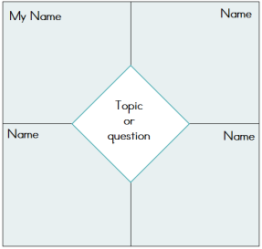**Conversation Roundtable:** Students fold piece of paper into fourths, then fold over the center corner into a small triangle. When opened, the paper is divided into sections as shown. Students record their own notes in the upper left quadrant. Four students then participate in a discussion. As students listen to what the others are saying, they record notes in each of the other three quadrants. One use of the conversation rountable is as a video reflection tool.
* **Carousel:**   
    
    
  Small groups of students rotate to posters around the classroom. Students respond to, discuss and post answers to images/prompts/questions on the posters and reflect on other students’ comments.
* **Collaborative poster:** Small groups of students collaborate to create posters with specific visual information (drawings and text). Each student uses an assigned colored marker. Each student is accountable for creating and presenting their contribution to the poster. Students discuss critically, explain, and make decisions to complete this task.
* **Fishbowl Discussion:** Fishbowls involve a small group of students seated in circle having a conversation (fish). They are surrounded by a larger group of observers seated in an outer circle (bowl). The facilitator gives a short input of 5-10 minutes which sets out the general outline of the discussion. After that the inner circle starts to discuss while the outer circle listens and observes. Students are moved between the inner and outer circles so that all have an opportunity to participate in both roles.
* **Socratic Seminar:** Students engage in a formal discussion, based on a text, in which the leader asks open-ended questions. Within the context of the discussion, students listen closely to the comments of others, thinking critically for themselves, and articulate their own thoughts and their responses to the thoughts of others.  They learn to work cooperatively and to question intelligently and civilly.