**Guidelines for an Effective Close Read**

[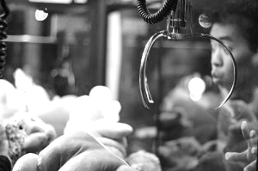](http://www.teachingthecore.com/wp-content/uploads/2013/04/close-reading-claw-game.jpg)

Close reading is kind of like the claw game — the work of close reading is the analyzing the stuff animals, choosing carefully, aligning the claw, going down, and grabbing; the pay-off is when this work is pulled out into the real world for discussion, debate, or writing.

* **Introduce complex vocabulary:** At most, we’ll explicitly teach/introduce 10 vocabulary words in a given document. We usually choose these words based on how crucial they are to understanding the piece and/or how difficult or unfamiliar we think they’ll be to our average students.
* **Establish a purpose:** This is where we try to hook our kids into the text. We might give background information, read an interesting section, or connect it to prior learning. We then seek to give students a clear, legitimate task or purpose.
* **Model higher-order reading/thinking:** Here, we just read aloud a portion of the text, “showing” our thinking as we go through a paragraph or two. We try to show students how we stay focused on a reading purpose, how we appreciate craft, how we grapple with unfamiliar vocabulary, and how we annotate.
* **Partner practice:** After modeling, we set the students loose on a paragraph or two, but instead of having them read independently we may ask them to read aloud in pairs, annotating as they go. When finished, we have them share something they annotated. This forces them to stop and think while they are reading.
* **Check for understanding:** When our students are working in pairs or independently, we walk around, monitoring their work. Are they creating useful annotations? Are they slowing down enough to record their thinking in response to the text?
* **Independent practice:** Finally, the students are cut loose. Our goal is to give them at least two shots at this every week.